**Name : محمد شعبان حسن عبد الهادي حسن**

**B.N: 728**

**Topic:** ***operating system***

**Github link :**   <https://mohammed-shabaan.github.io/ECE001/>

**Github page :** <https://github.com/mohammed-shabaan/ECE001>

**Examiner committee**

|  |  |
| --- | --- |
| **1** | **Dr. Ahmed Bayoumi** |
| **2** | **Dr. Shady Elmashad** |
| **3** | **Dr. Abdelhamid attaby** |

**Application brief :**

An operating system (OS) is system software that manages computer hardware, software resources, and provides common services for computer programs. Time-sharing operating systems schedule tasks for efficient use of the system and may also include accounting software for cost allocation of processor time, mass storage, printing, and other resources. For hardware functions such as input and output and memory allocation, the operating system acts as an intermediary between programs and the computer hardware, although the application code is usually executed directly by the hardware and frequently makes system calls to an OS function or is interrupted by it. Operating systems are found on many devices that contain a computer – from cellular phones and video game consoles to web servers and supercomputers.

Operating System Basics

On a fundamental level, an operating system manages virtually every aspect of the user experience. From the moment you start your computer to the final second before it shuts down, the operating system is playing a fundamental role in its functionality. Far from simply acting as a conventional software package, the operating system connects with your computer's CPU, as well as various memory and storage. Just as the motherboard acts as the central hub between all hardware parameters within your computer, the operating system acts as a liaison for software, hardware and user.

**Screenshots :**

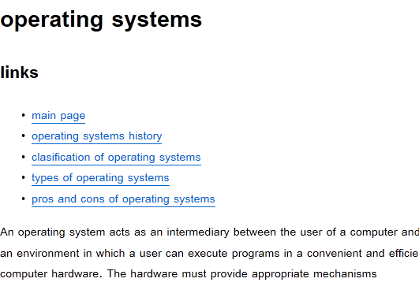

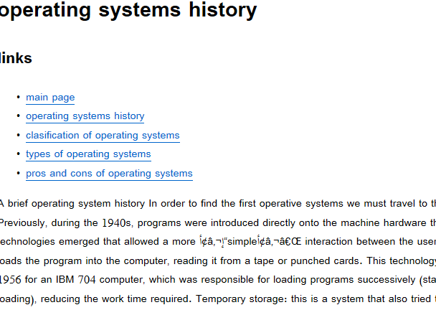

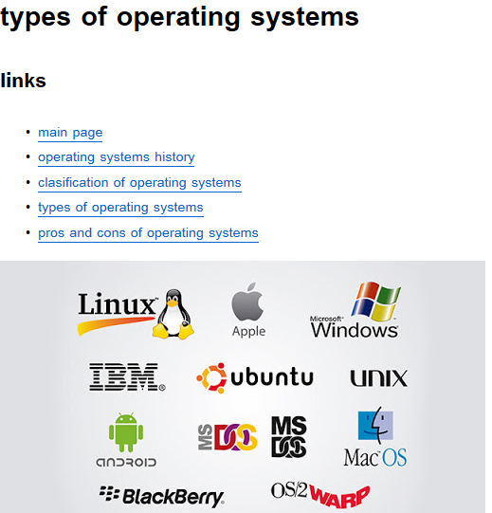

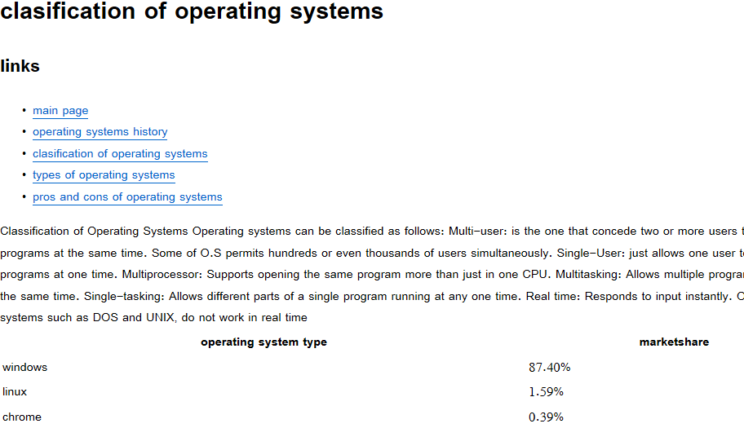

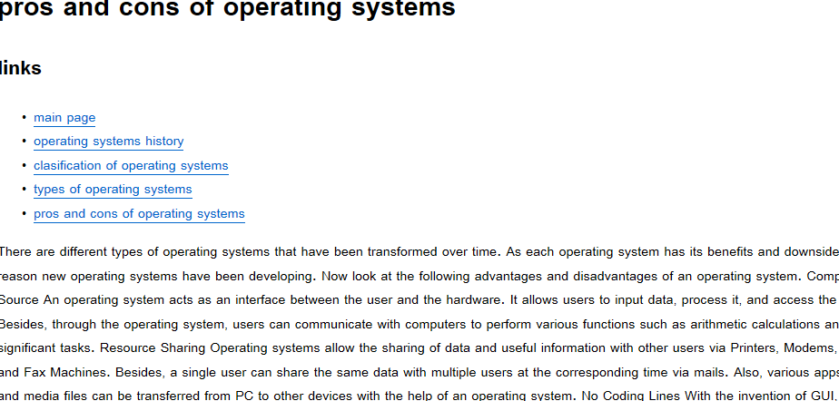

**Source code**

